**static Website Deployment**

Step1:search EC2  in services>dashboard> click on launch instances

Step2: in name and tags:staticapplicationec2instance( Type your instance name)

AMI ->amazon linux 2023 AMi free tier

instance typer:t2.micro

keypair(login)-too securely connect to instance connect ec2 to local instance

 create a new keypair with keypair name  and the type as RSA

private key format : pem

allow ssh trafic

allow HTTPS traffic

allow HTTPS traffic from the internet ,select all three.

Step3:

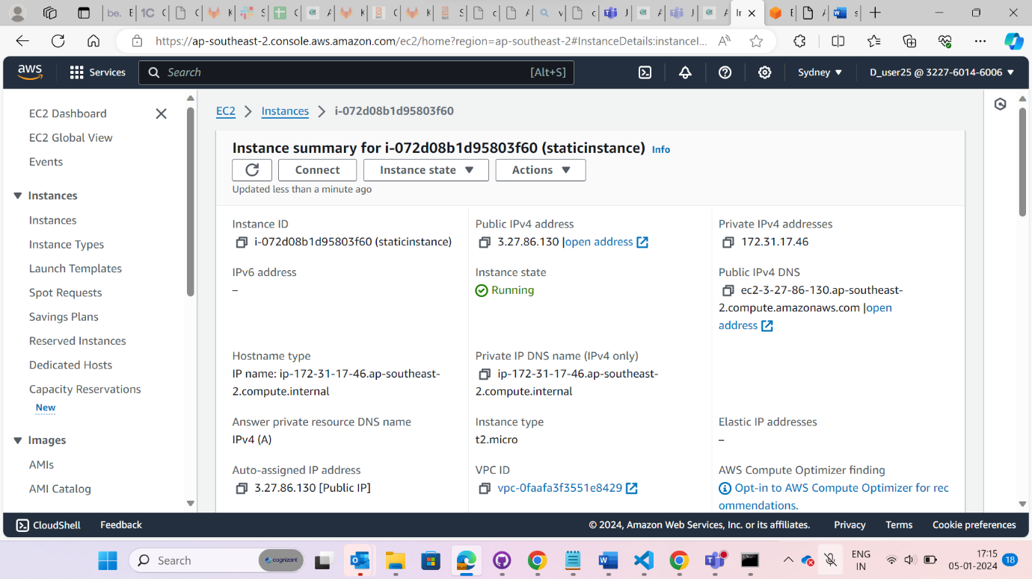

launch instances and the instances will be created successfully.

Step 4: from the above image as reference click on connect.

Give the username and click on connect.

Step 5:

Once you click on connect it will redirect to this page

Step 6: copy the static website folder make a copy of zip create a new folder and paste the zip file and pem file.

Step7: open the command prompt from the location and type

scp -i ./statickeypair.pem cloudProject.zip [ec2-user@ec2-3-27-86-130.ap-southeast-2.compute.amazonaws.com:~](mailto:ec2-user@ec2-3-27-86-130.ap-southeast-2.compute.amazonaws.com:~)

cloudProject.zip

Steps 8:

Now in aws, follow the above command

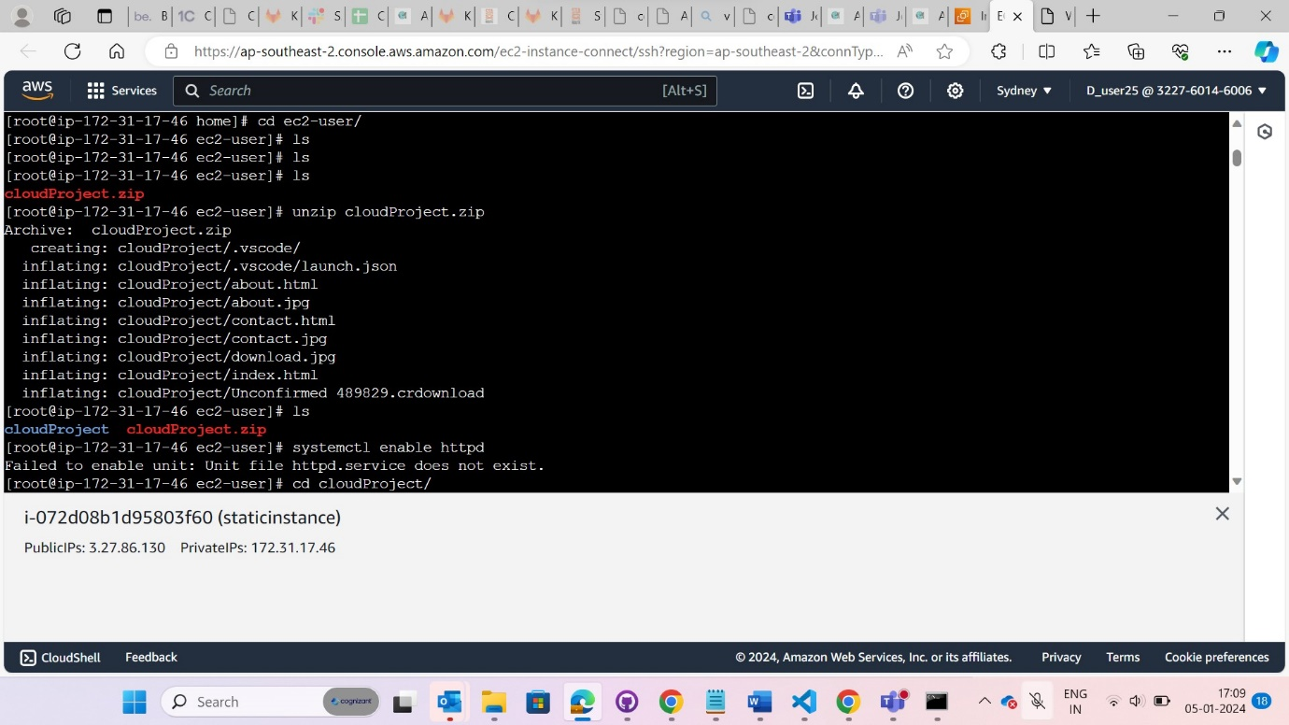

Step 9:

Unzip and folder

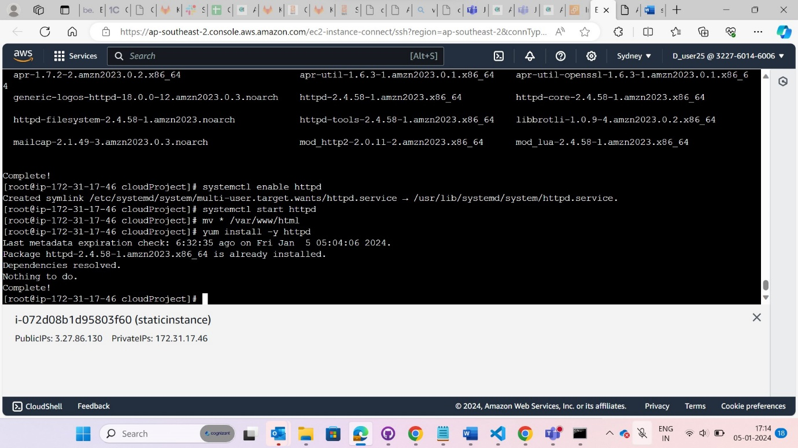

Step10:

Now finally click on public ipv4 address it will redirect to the output page.

**Home page:**

**About Page:**

**Contact Page:**

